Pre-K & Kindergarten Supply List
2022-2023
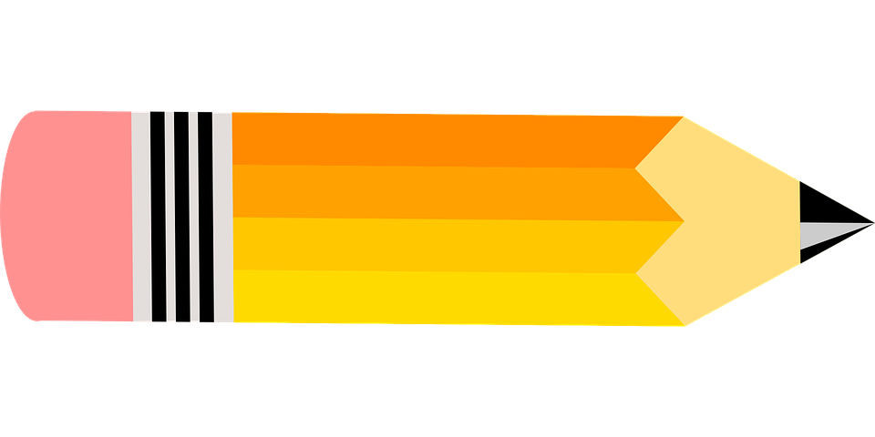
  - Backpack, 13.75'' x 7.5'' x 17'' (or big enough to fit folders without folding in half)
Link for size referral: https://www.potterybarnkids.com/tips-and-ideas/pbk/what-size-backpack-for-kindergarten/
  - Lunchbox
  - Blue 2 pocket folder
  - 3 boxes Crayola crayons
  - 3 boxes Crayola Markers
  - 2 sets Crayola Watercolors
  - 1 pair child scissors
  - 2 boxes Crayola colored pencils
  - 1 pencil box, 13.5” x 5” (must be this size or similar to fit into desk)
  - 1 ream of copy paper 8/12 x11
  - White 1” 3 ring binder
  - 3 rolls paper towels

